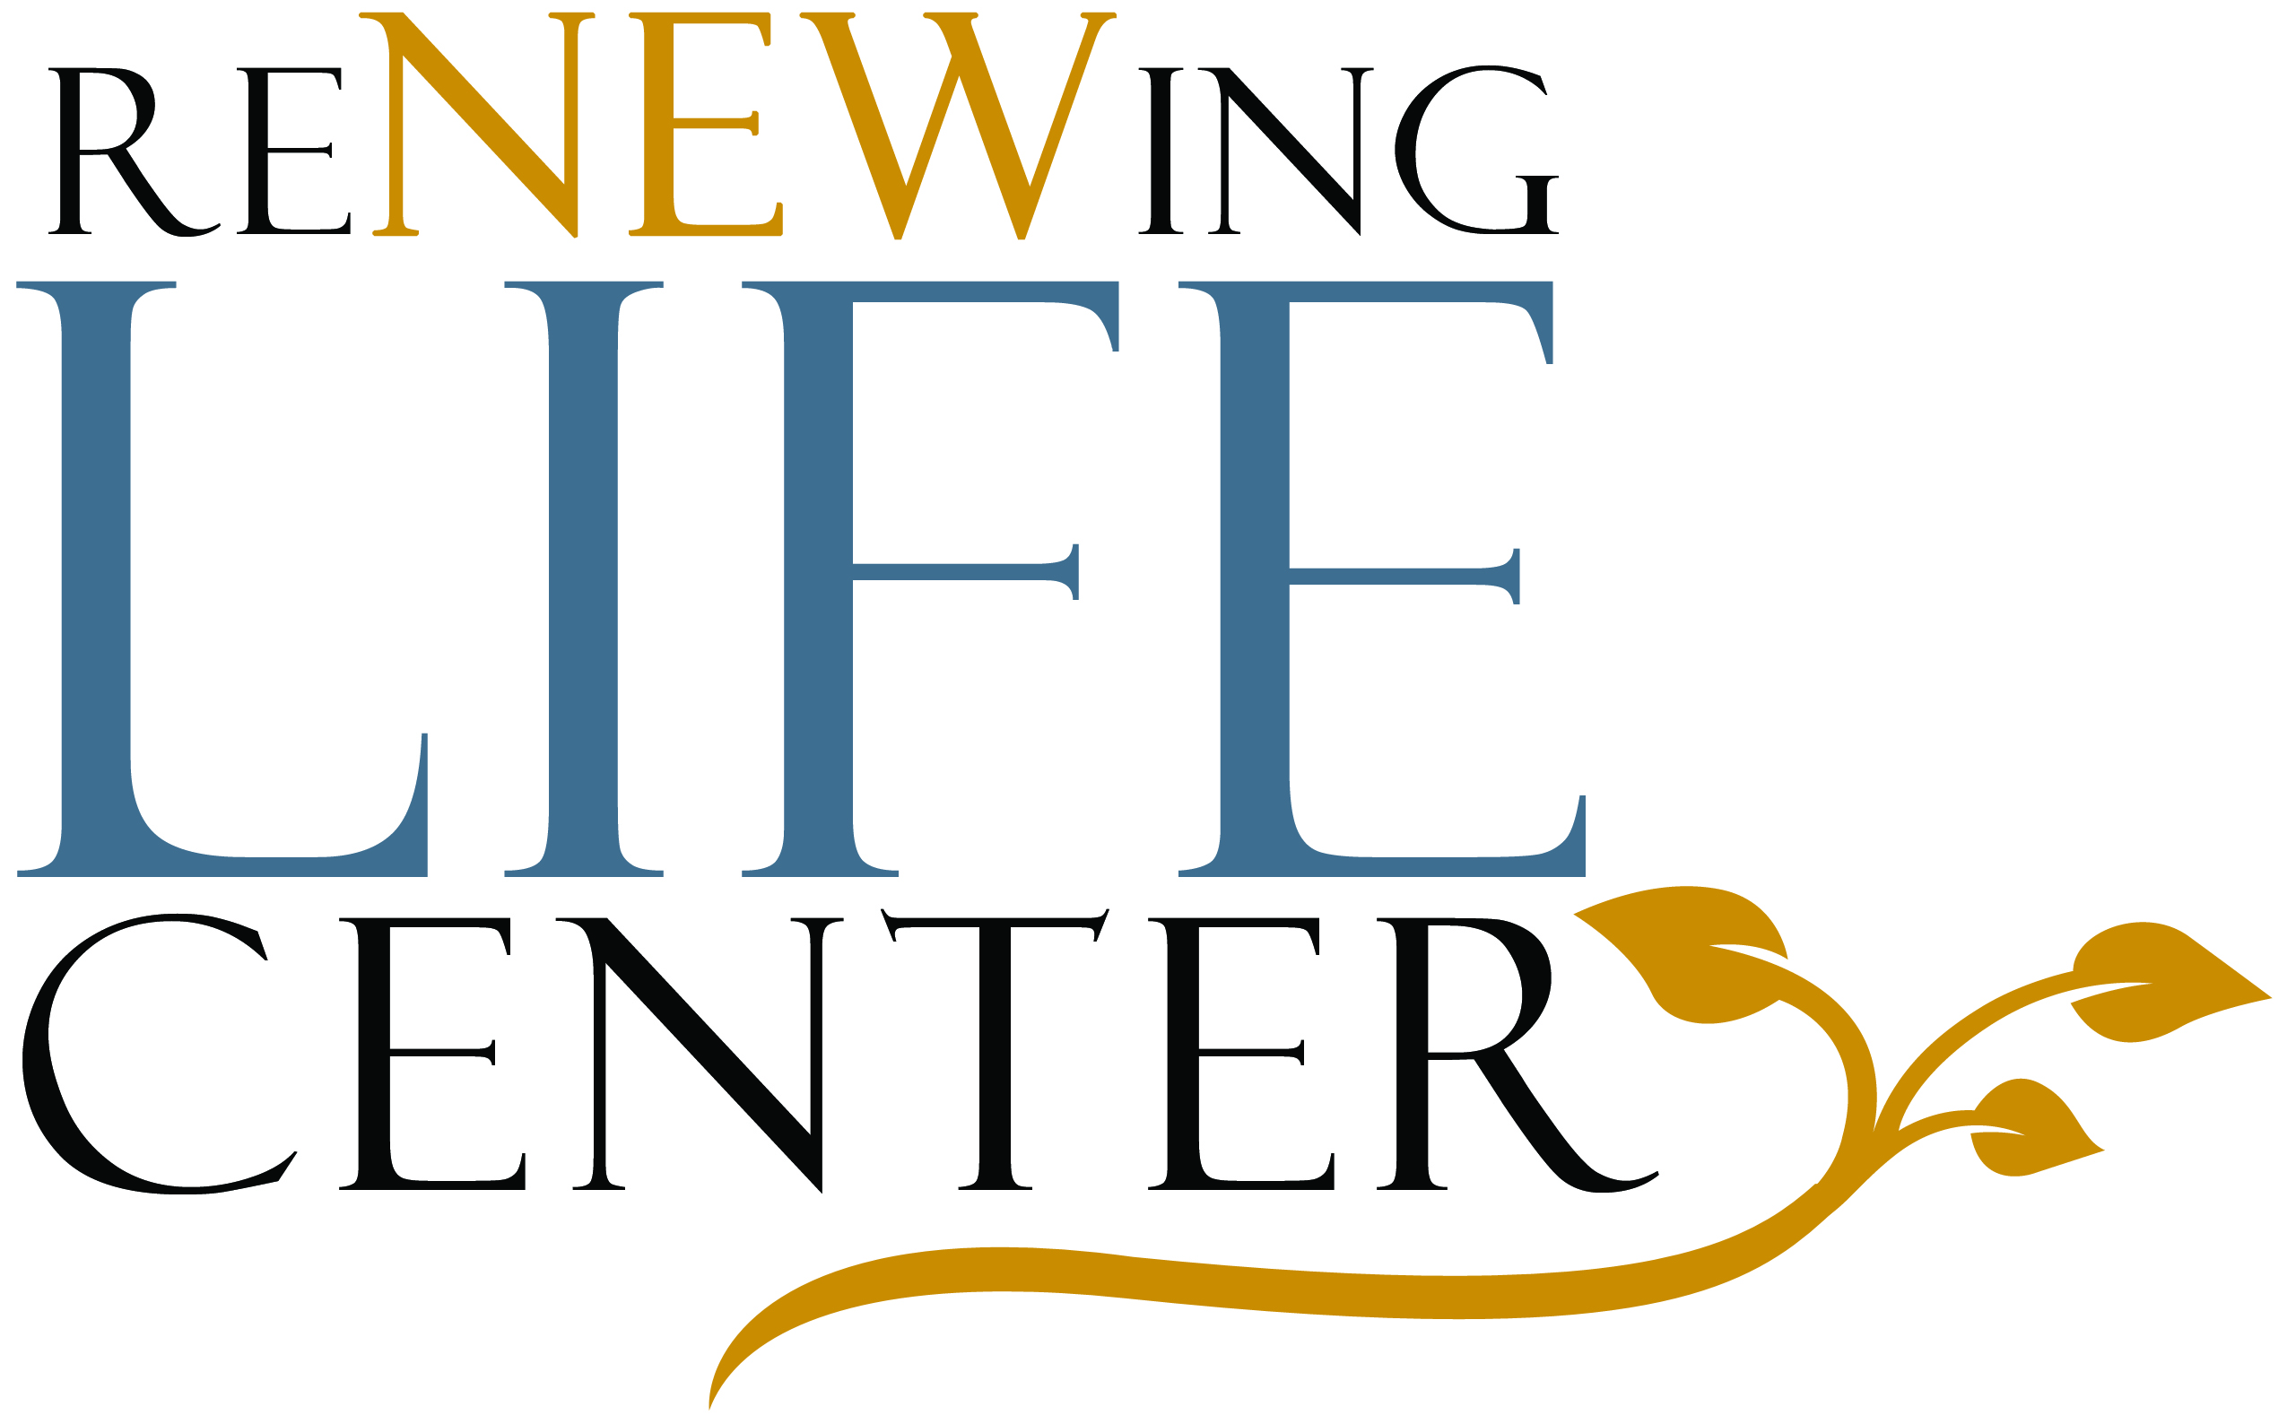 3243 E. Warm Springs Rd.
Las Vegas, NV 89120
(702) 434-7290

RELEASE OF INFORMATION
(for Minor Child)

I, ________________________________________, hereby authorize the Renewing Life
Center to release any and/or all information pertaining to my evaluation and/or counseling sessions for myself/those listed below for whom I am the legal caretaker.

Others covered in this authorization: _________________________________________

_______________________________________________________________________

Specifically, I authorize the Renewing Life Center to release the above information

to:_____________________________________________________________________

for the purpose of:________________________________________________________
(indicate the specific reason)

_______________________________________________________________________

I understand that authorization shall remain valid from the date of my signature below

and for twelve (12) months thereafter ending on:________________________________

I understand that my records are protected under Federal and specific State confidentiality laws and cannot be disclosed without my written consent unless otherwise provided for in the regulations. I also understand that I may revoke this consent at any time except to the extent that action has already occurred. I further acknowledge that the information to be released was fully explained to me and this consent given of my own free will.

_____________________________________________ ________________________
(Client, parent, guardian, or other authorized person to sign) Date

_____________________________________________ ________________________ (Client, parent, guardian, or other authorized person to sign) Date

